
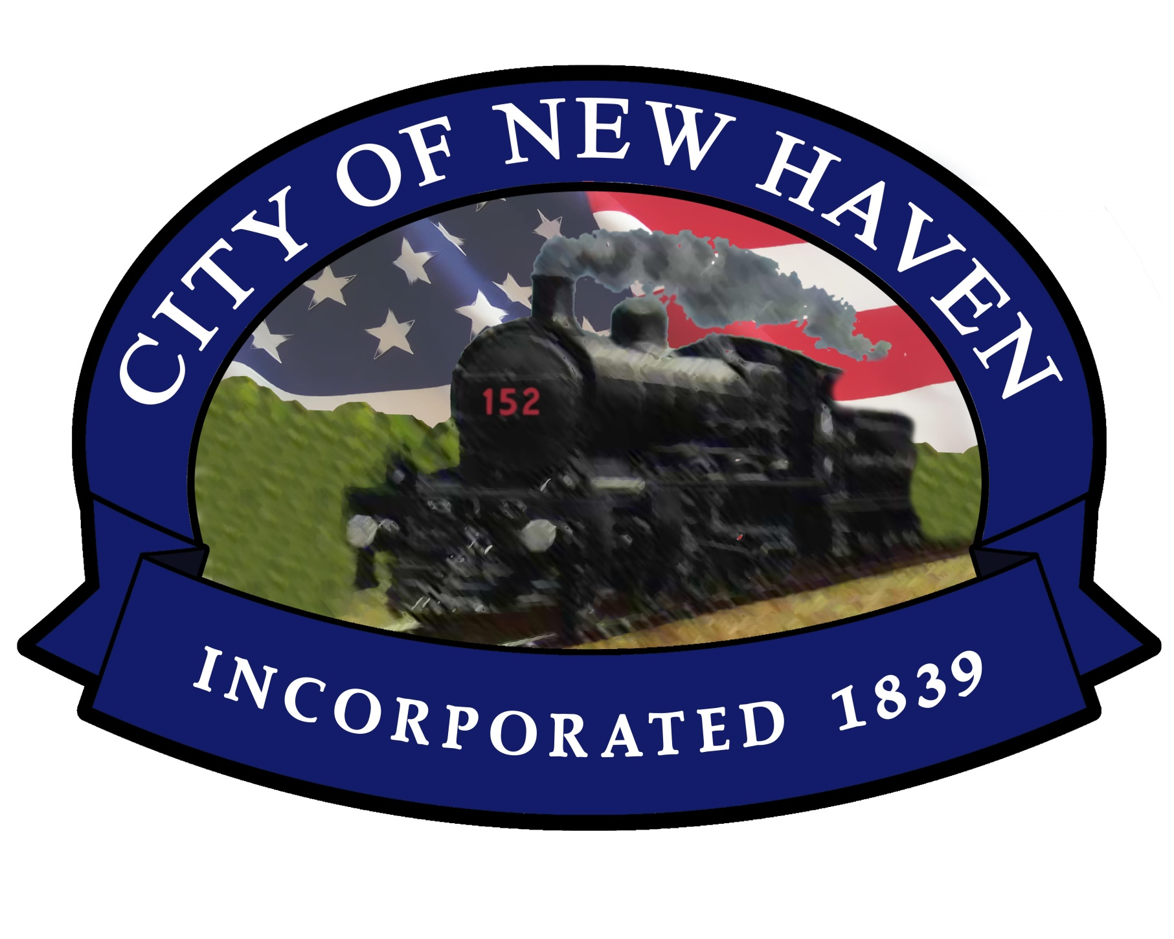

Organization Name:_______________________________________

Contact Person: __________________________________________

Email Address:___________________________________________

Phone #:________________________________________________

Mailing Address:_________________________________________
_______________________________________________________

Description of Entry
Feel free to add a page with more information
_________________________________________________________________________________________________________________________________________________________________________________________________________________________________________________________________________________________________________________________________________

Only children Santas are allowed on floats!
No adult Santas!
We appreciate your participation!

“Small Town….Big Christmas”

Entry Form
Sunday, December 7 @ 5:15PM
New Haven Christmas Parade

